Circle of Knowledge
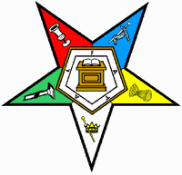
Test your knowledge of the Order of the Eastern Star References
The Circle of Knowledge Test will be a fifty question test given on
Thursday, September 26, 2019 at 1:00pm.
Tamarind Room at Kalahari.

It will include questions on: the Grand Chapter of Ohio Bylaws relating to Subordinate Chapters, Book of Instructions, The Book on Protocol, and The Ritual of the Order of the Eastern Star

If you complete the test with a score of 90% or better, then you will receive a Circle of Knowledge pin on Saturday at Grand Chapter. The person with the top score will receive a plaque donated by the Education Committee.

Register to take the test by completing the form below and mail to:
Nancy Williams, 1079 Doster Road, Wilmington, OH 45177

Name:
Address:
City: State: Zip:
Cell Phone: E-Mail:
District: Chapter: Number:

