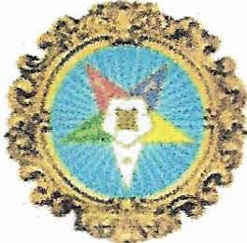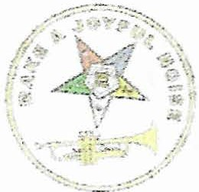

DISTRICT 10
EDUCATIONAL OPPORTUNITY #1

Connecting, Building, Growing

V HO:

WHAT:

WHEN:

WHERE:

ALL MEMBERS

AN AFTERNOON OF LEARNING AND FELLOWSHIP

Meet the Deputy Grand Matron and members of District 10 as we explore some points of our Ritual and Book of Instruction. The primary topic for the day will be INSTALLATION procedures. Grand Law changes made at Grand Chapter will also be reviewed.

This will be a participating time, so come, learn how to connect, build, and grow with your Sisters and Brothers

October 6, 2019

Cornelia Chapter #93 303 S. Madison Street Republic, Ohio

WHY: FOR LEARNING! FOR FUN!

Dress is casual (please no jeans).

Bring your Ritual, Grand Law, and Book of Instruction.

HOPE TO SEE YOU ON OCTOBER 6, 2019

