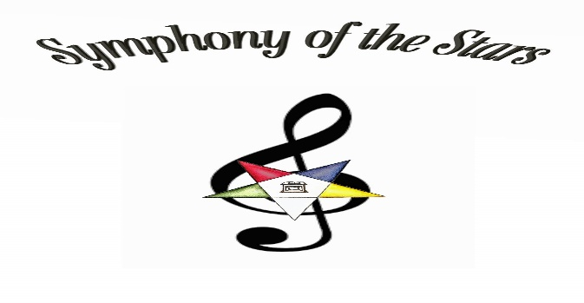
REGIONS F, G, & H
DISTRICTS 9, 18, 19, 20, 21,22
CORDIALLY INVITE YOU TO ATTEND
EDUCTIONAL OPPORTUNITY #2
SATURDAY, NOVEMBER 2, 2019
DAYTON MASONIC COMPLEX
525 W. RIVERSIDE DRIVE
DAYTON, OHIO 45405

MARGARET (MARGI) WHEELER, WORTHY GRAND MATRON
CHARLES (CHUCK) MERCKLE, WORTHY GRAND PATRON

9:00 – 1:30 Registration (ends when General Session begins)
9:30 – 10:15 Workshop 1 – Star Polishers
Workshop 2 – Membership
10:30 – 11:15 Workshop 3 – Presentations for Conductress & Associate Conductress
Workshop 4 – Appointed Officers
11:15 – Noon Line Officer Workshops (WGM/WGP meet with WM/WP;
AGM/AGP meet with AM/AP; GC/AGC meet with C/AC
11:45 – 1:00 Lunch (Reservation Only)
1:30 – 3:30 General Session

* * * * * * * * * * * * * * * * * * * * * * * * * * * * * * * * * * * * * * * * * * * * * * * * * * * ** * * * * * * * * * * * * * * *
MEAL INFORMATION:
BOX LUNCH – CHOICE OF HAM & CHEESE CROISSANT OR TURKEY & CHEESE CROISSANT, SALAD, CHIPS, COOKIE & DRINK
Gluten free or dairy free lunches are available upon request.
COST…$10.00 PER PERSON (EVERYONE PAYS) PROCEEDS FOR THE BENEVOLENCE FUND.
PAYMENT MUST ACCOMPANY RESERVATION
MAKE CHECKS PAYABLE TO: DISTRICT 21 ASSOCIATION – DEADLINE OCTOBER 20, 2019
MAIL TO: JOYCE HORNER, P. O. BOX 151, 314 W. MULBERRY ST., LEBANON, OH 45036

