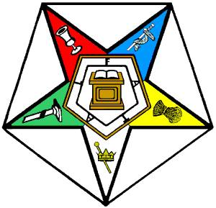
Grand Chapter of Ohio
Order of the Eastern Star

2018-2019 Nature’s Life & Beauty
Charitable Activities Report

On an annual basis, Chapters self-report their charitable activities on an Interim Report due January 15th and a Final Report due June 15th.

This year, we had 168 Final Reports (89%), including those from 4 chapters that merged during the year. We had 20 chapters that did not submit a Final Report; of these, we had partial data for 13 chapters that had submitted an Interim, incomplete (page one or two only), or unidentified (not marked Interim or Final) Report.

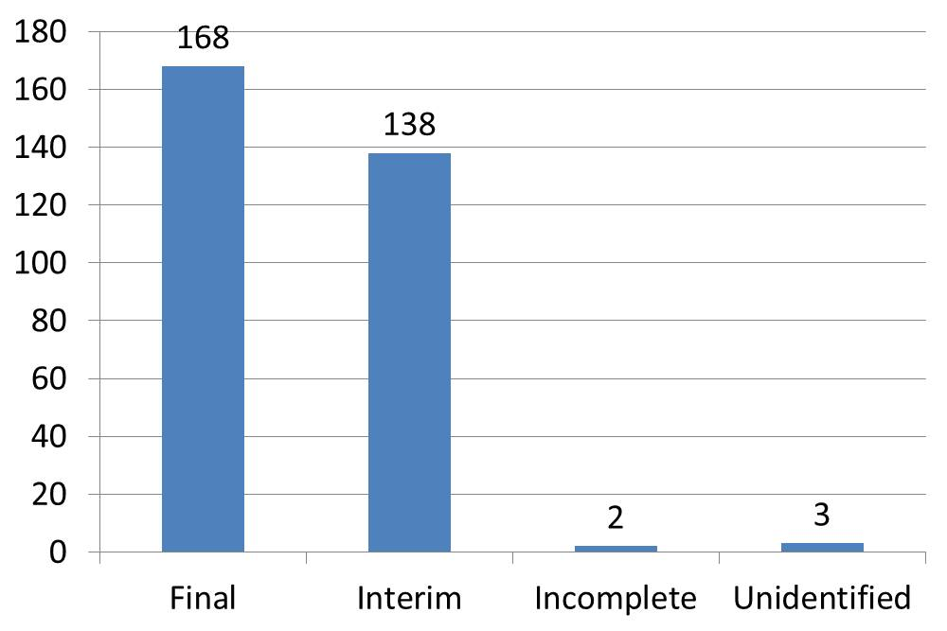

To this Chapter data, we added donations submitted by Districts, Charities Directors, and Individuals to the Grand Chapter of Ohio OES Charitable Foundation and the funds raised by the Grand Chapter Charities Committee for the WGM / WGP OES Home Project (trees).

Chapters significantly understate their charitable activities. In prior years, we only asked for Chapters to report donations of money. This year, we asked them to estimate the value of donated goods and chapter service hours. Only 71 chapters reported donated goods. 34 reported chapter service hours.

We are pleased to report that the total donations (money and goods) were $606,876.20.

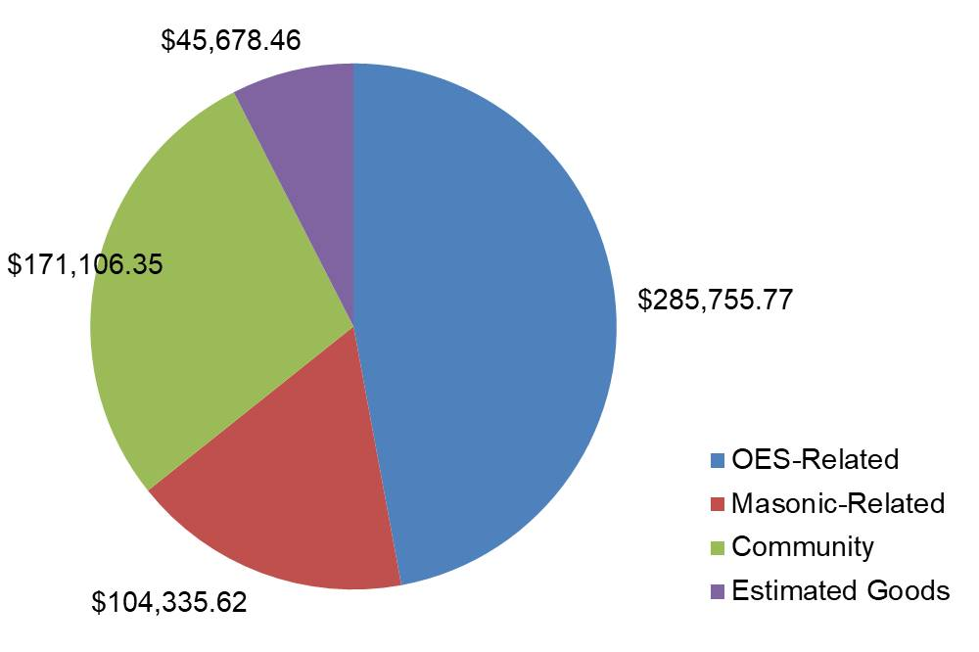

147 Chapters reported member volunteer hours. As mentioned previously, only 34 reported Chapter service hours. Our members are very active in community, as well as OES activities. A total of 329,055.25 hours were reported for 1,736 members.

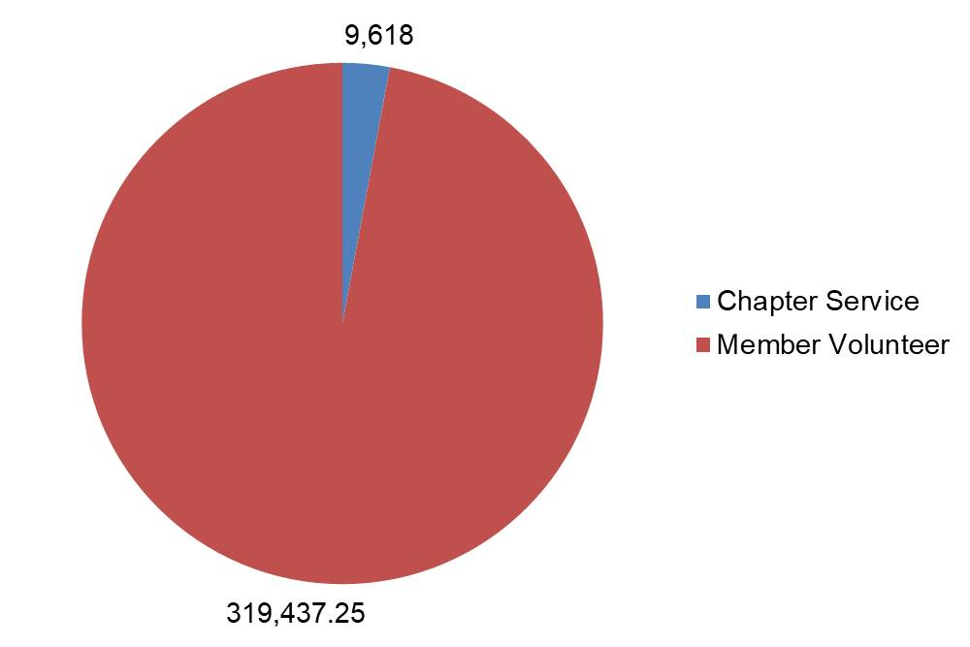

For 2019-2020, we recommend the adoption of a new reporting method, a log that is maintained from June 1st through May 31st and turned in by June 15th. Further, we recommend that this reporting requirement be extended to Districts and Charities Directors to enable us to capture a broader picture of our charitable giving.

