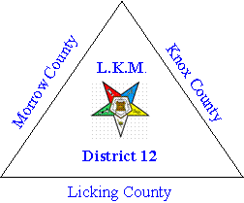
District # 12 Association of the
Order of the Eastern Star
Invites You to our Annual LKM Banquet
Recognizing:
Worthy Grand Matron, Margi Wheeler & Worthy Grand Patron, Chuck Merckle
Past Grand Patron and Grand Trustee, Bill Taylor
Grand Warder, Cheryl Maslowski
Deputy Grand Matron, Sharon Hickman
Grand Representative to New York, District #12 President, Suzanne Griffin
Grand Representative to Florida, Marcella Phillips
District 12 2020 Worthy Matrons
Saturday, February 22, 2020 at 6:00 pm
at the Gallagher Center
1451 Gambier Road Rd, Mt Vernon, Ohio, 43050
Buffet Dinner Including Swiss Steak & Lemon Garlic Chicken Breast,
Vegetable, Potatoes, and Dessert
Coffee, Iced Tea, or water
Make your reservations by sending your check made payable to the:
District #12 Association of Chapters
for $25.00 per person.
Mail to: Suzanne Griffin
1136 Country Club Drive
Newark, Ohio 43055
RSVP By February 8, 2020

Please return this lower portion with your check and number attending:
Total enclosed at $25.00 per person $__________

Names______________________________________________
Phone Number

