CINDY’S BEE T.E.A.M.
Cindy Chadwell Associate Grand Matron 2021
Contact information below
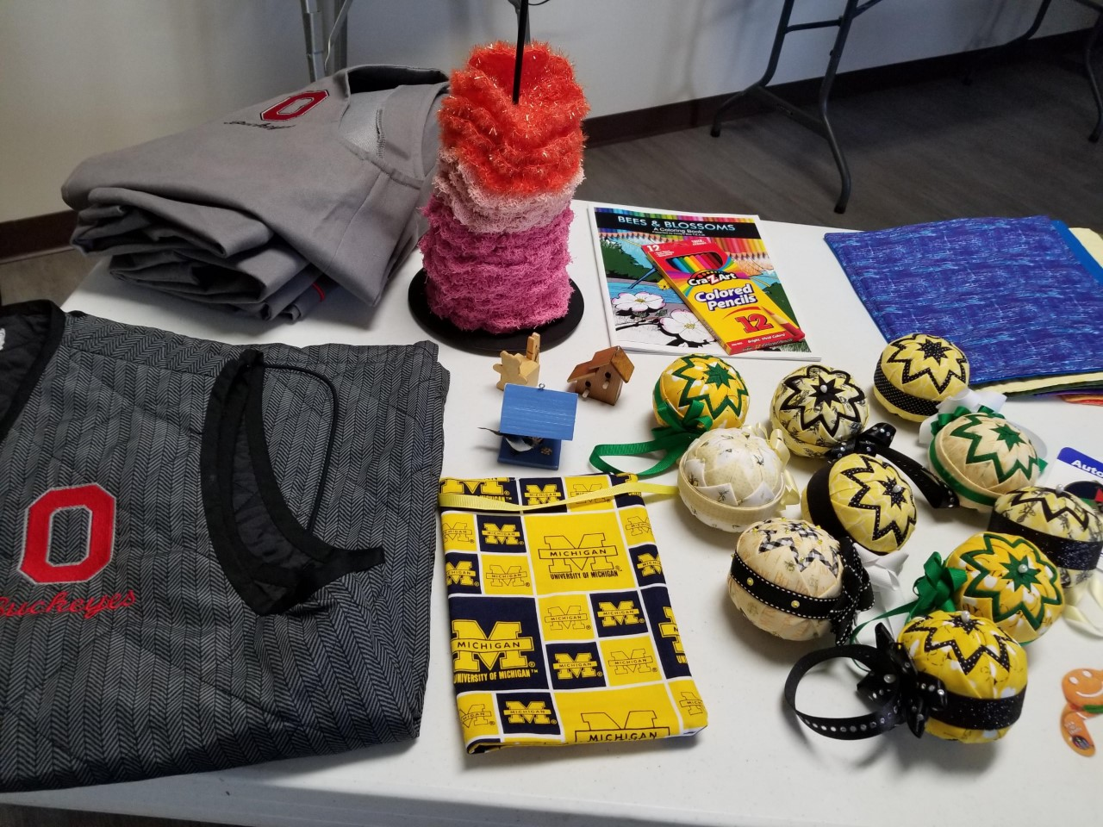
OSU gray vests $25 each. Sizes available: (2) Medium and (2) extra large
OSU black vest $25 size (1) XXL
Michigan large ritual book cover $10
Bee material ornaments $10 each
Bird houses blue and brown $1 each
Teddy bear recipe holder $1 each
Scubbies $1 each colors available: dark pink, light pink and orange
Coloring book with box of colored pencils-$10 (pictures in book all drawn by Jason Chadwell the AGM son)
Plate cozies (use in microwave to keep hands from picking up hot plates) $5 each

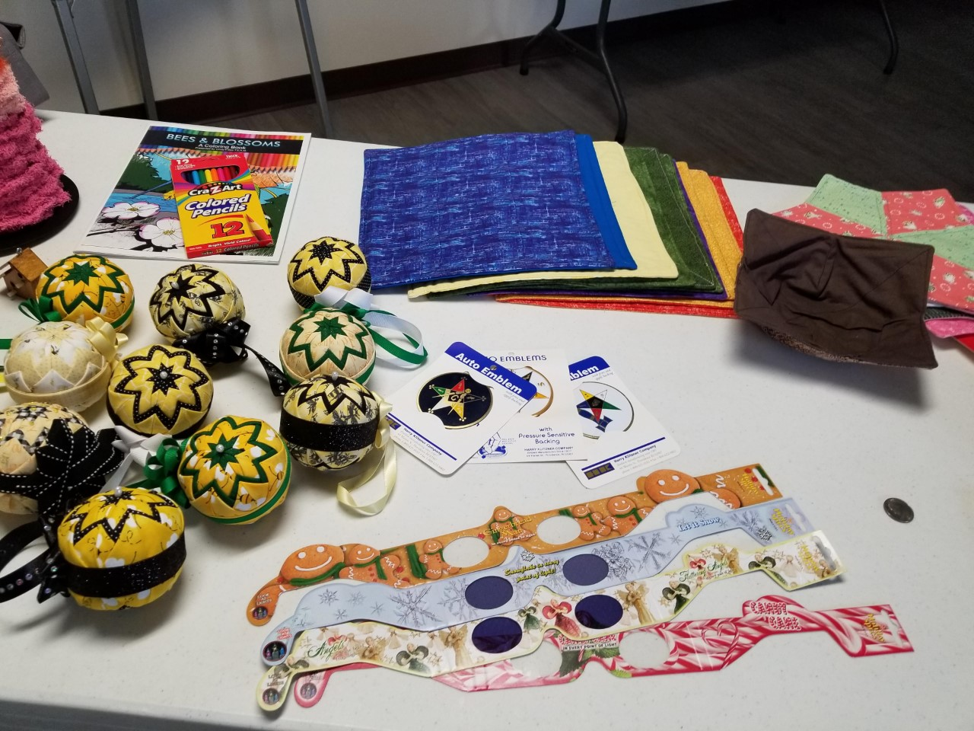 Bee material ornaments $10 each
Coloring book with a box of colored pencils $10 each
Plate cozies $5 each
Auto emblems $1 each available: masonic in center of OES star on dark blue background, OES star with white background, and OES star with gravel on white background
3D glasses $2 each available: gingerbread men, snowflakes, angels and candy canes
Star Trivets $5 each various colors and patterns
Soup Cozy $5 (1) brown

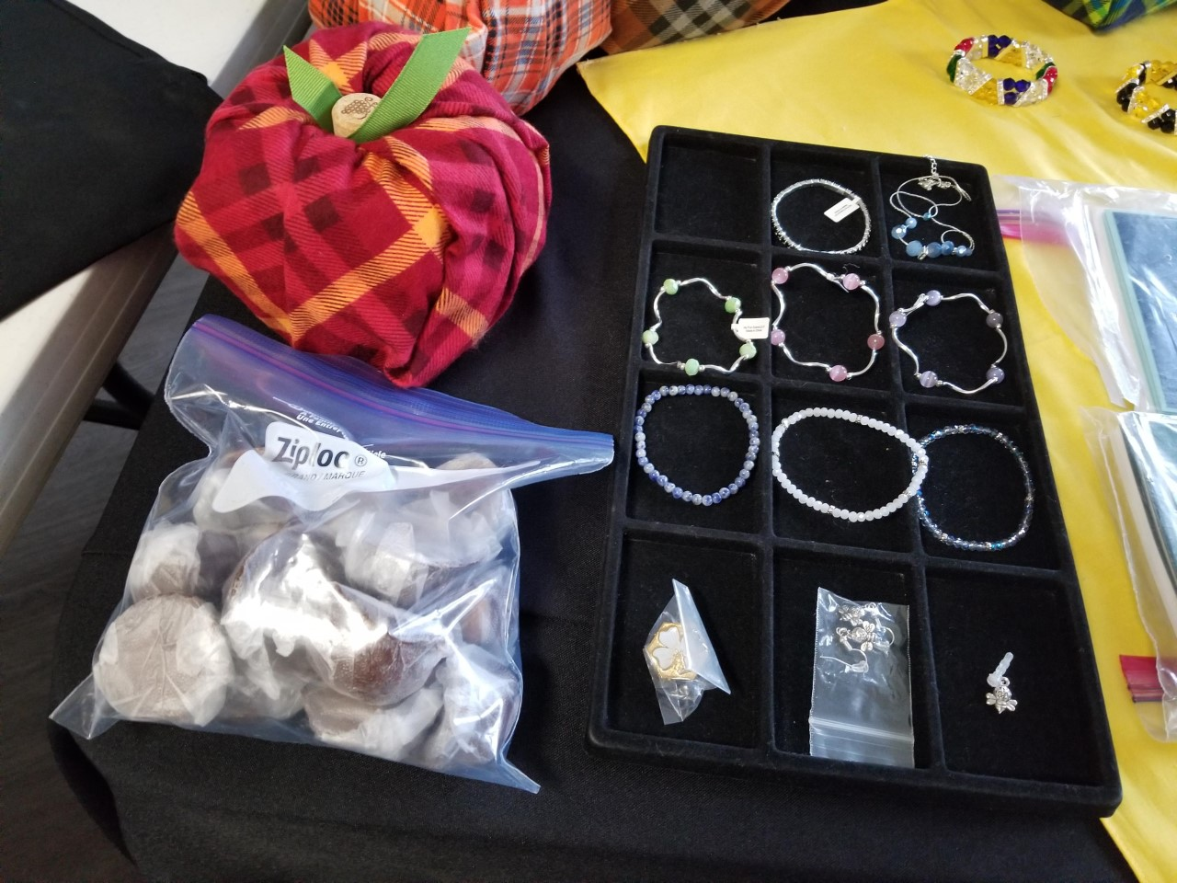Pumpkin décor $5 each
Buckeyes $1 each Homemade by a Triangle Chapter member
Cindy’s dogwood/bee pin $7 each
Bee wire earrings $5 pair
Bee phone charm $1 each
Blue and white bracelets $5 each
Yellow green/silver, Pink/silver, and Lavender/silver bracelets $5 each
Black/silver bracelet $5 each
Blue/Silver necklace-$10 (only 1 available)

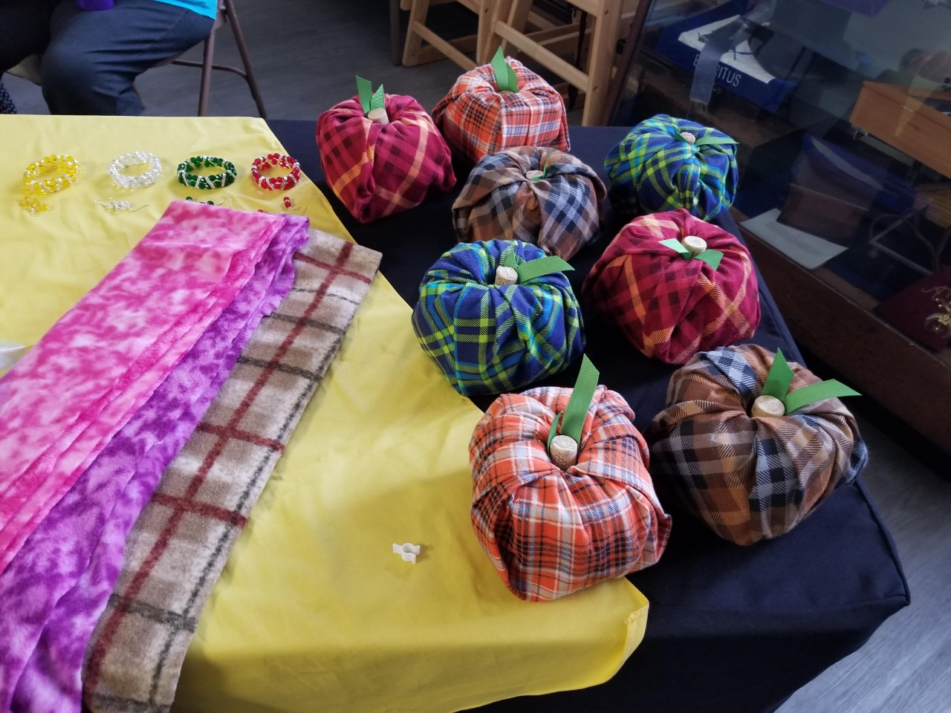Handmade winter scarves $8 each (various colors feminine and masculine)
Pumpkin décor $5 each

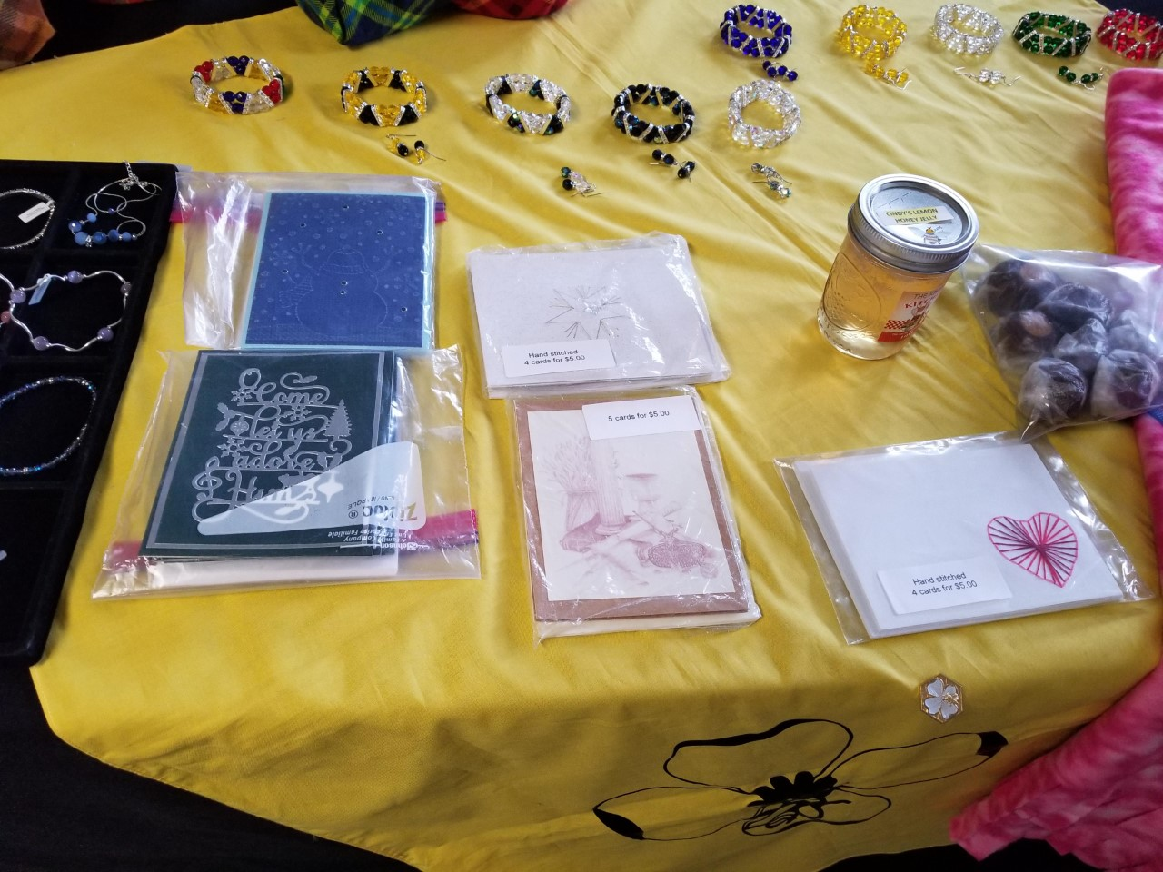
Beaded bracelets $15 each (colors available: OES colors, yellow/black, black/clear, black, dark white, blue, yellow, white, green, red)
Matching beaded earrings $5 each (same colors as bracelets)
Handmade greeting cards $5 per package (available: green Christmas, Blue snowman, Star points, silver/gold star and heart) 4 or 5 cards per pack
Lemon-Honey jelly $5 per jar

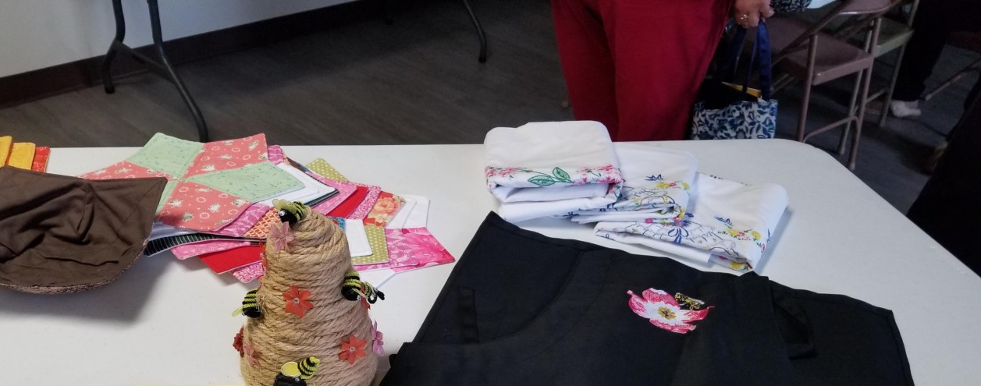
Apron-adjustable $20 each
Star Trivets $5 each various colors and patterns
Soup Cozy $5 1 brown one left (for use in microwave for bowls, or for ice cream bowls)
Pillowcases $15 a pair (available: 1 blue bonnet and 1 pink flowers) (This may not be correct) Supplies are with 3 different people and have not heard from one to know what she has) Check with me.

Contact Brenda Slay, Secretary Cindy’s BEE T.E.A.M.
614-893-6344 (text or phone call)
EMAIL: bkslay1@hotmail.com
If your Chapter’s installation is being held let me know when and where when you order and I will check with AGM to see if she is attending and she can bring your item(s) and collect payment.
If writing a check make it payable to 17th District Steering Committee

