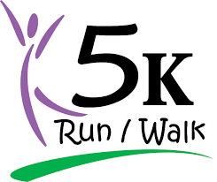Registration

Name:_______________________________________________________________
Address:___________________________________City____________________State_____
Phone:____________________ Email:__________________________________________

I’m enclosing my registration fee of $40.00* per person: ______ x _________=_$___________
*(includes a donation to Regenerative Medicine: WFIRM + OES=IMAGINE)
Please make checks payable to Grand Chapter of Ohio, OES Inc.
REGENERATIVE MEDICINE in the memo……
Registration to : Pam Moore 853 Terry Ln. Urbana, OH 43078
(registration deadline: May 01, 2021)…

************************************************************************************

OHIO STEPS UP FOR REGENERATIVE MEDICINE
I’m excited! I am walking/running for REGENERATIVE MEDICINE!! Come and walk with me!!
Run or walk your 5K (3 miles) between May 9-14, 2021……Let’s have some fun!!

Sponsored by Grand Chapter of Ohio, Regenerative Committee 2021

