WFIRM + OES = IMAGINE
First annual 5K VIRTUAL run/walk
May 9-14, 2021
$40.00 (includes donation to Regenerative Medicine)
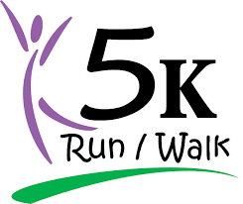
COME WALK WITH ME
Run or walk your 5K (3 miles) between May 9-14, 2021
- Wear OES attire and WFIRM bracelet and or pin
- Carry a sign to support the project
- Take selfie/interview people on your walk
- Post photos and videos on social media using #HIGHFIVE4REGMED21)
OHIO STEPS UP FOR REGENERATIVE MEDICINE
PARTICIPANTS RECEIVE:
Commemorative 2021 medal (limit to only the first 200 participants)
Photo Featured at Grand Chapter
Finisher’s certificate
Surprise gift for participants

Registration to: Pam Moore 853 Terry Lane Urbana, OH 43078
(Registration deadline :May 01, 2021)

Make checks payable to: Grand Chapter of OHIO,OES Inc. and note :regenerative medicine in memo

Sponsored by GRAND CHAPTER OF OHIO, REGENERATIVE MEDICINE COMMITTEE 2021

