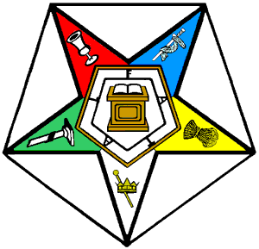Grand Chapter of Virginia

O. E. S.

*Robbin C. Hall Paul S. Shelton*

*Worthy Grand Matron Worthy Grand Patron*

*206 Okie Drive 685 Fairmont Road*

*Martinsville, VA 24112 Gretna, VA 24557*

February 5, 2021

To: Marianne Shenefelt, Most Worthy Grand Matron; Henry Martin, Most Worthy Grand Patron;

General Grand Chapter Officers; Worthy Grand Matrons and Worthy Grand Patrons of Other Jurisdictions; and Grand Secretaries of Other Jurisdictions

Dear Sister and Brothers,

Greetings from the Grand Chapter of Virginia! Eleanor Roosevelt said it best, “If life were predictable it would cease to be life, and be without flavor." Well, I must say that we all have had our fair share of flavor since March 2020 and the spice continues!

Virginia is, once again, planning its 116th S.M.I.L.E – Star Meetings in Love & Education Session to be held May 17-18, 2021 at the Roanoke Civic Center’s Berglund Special Events Center in Roanoke, Virginia. Our Grand Chapter Session will be an abbreviated itinerary for Virginia members only, as we continue to deal with ongoing restrictions due to the Coronavirus. We appreciate your understanding and please know that we will miss all of you! We ask God for His Grace and Mercy on our world, so we may all gather again to celebrate our beautiful Order in friendship.

We wish for each of you continued health and wellness. We look forward to hopefully greeting you at our 117th Grand Chapter Session in May 2022.

May the Lord bless you with a Smile on your face and Love in your heart!

Sincerely & fraternally,



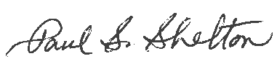

Robbin C. Hall Paul S. Shelton

Worthy Grand Matron Worthy Grand Patron