Mary Drushella, WGM
P O Box 68257
Oak Grove, OR 97268
503-342-8911

Grand Chapter of Oregon
Order of the Eastern Star

March 9,2021

Dear Sisters and Brothers,

Grand Chapter Session “Believe” planned for June 20 - 23, 2021 at Pendleton Convention Center has been cancelled due to COVID-19. The decision was extremely difficult but based on the vaccination schedules and the uncertainty of how many people will be allowed to gather it was the only one to make.

An abbreviated session is planned for Monday June 21, 2021 at the Pendleton Convention Center. I am sorry to inform you that this one-day Session will be for Oregon Members ONLY. We will take care of essential business, the election of Officers, and Installation of the new Grand Officers.

Oregon is going to miss having our Sisters and Brothers from other Grand Jurisdictions and Concordant Bodies visit. I look forward to the day that we may join each other again.

More details will be provided in the registration packets to our Oregon members.

Stay humble – Work hard – Be kind!

Star Love,

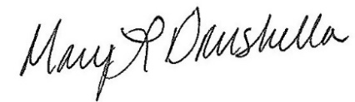
Mary Drushella, Worthy Grand Matron

