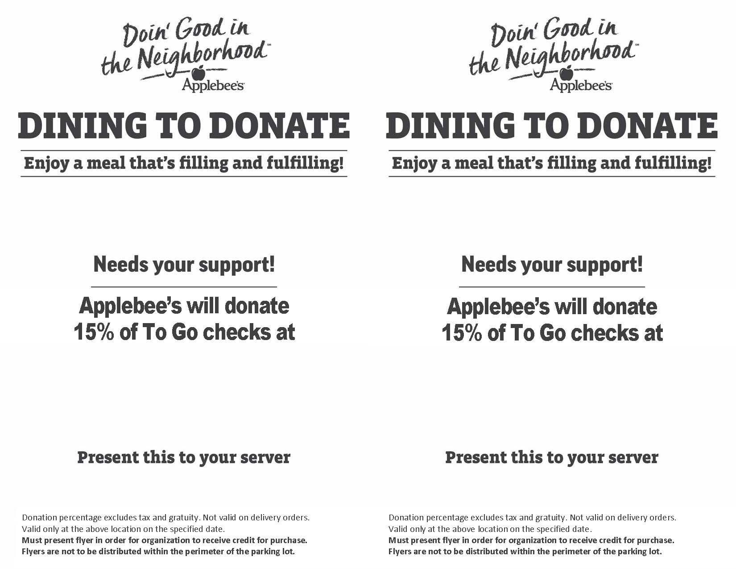

**GRAND CHAPTER OF OHIO:**

Ashtabula, 3241 North Ridge Drive  
(440) 998-1411  
Strongsville, 17771 SouthPark Center

(440) 572-5292  
Lorain, 4320 Leavitt Rd (440) 282-4442  
Akron, 2897 Arlington Rd (330) 644-5303

Thursday, April 15th 11am-9pm

**SERVICE DOG COMMITTEE**

**GRAND CHAPTER OF OHIO:**

Ashtabula, 3241 North Ridge Drive  
(440) 998-1411  
Strongsville, 17771 SouthPark Center

(440) 572-5292  
Lorain, 4320 Leavitt Rd (440) 282-4442  
Akron, 2897 Arlington Rd (330) 644-5303

Thursday, April 15th 11am-9pm

**SERVICE DOG COMMITTEE**