 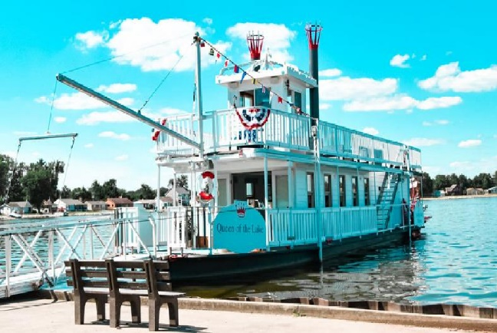

**Cheryl Maslowski’s steering committee (Cheryl’s Shimmers)**

**Invites you to a fundraiser “cruise” around Buckeye Lake State Park**

**Sunday, August 29, 2021**

**2:30 pm arrival time**

**box lunch provided to enjoy on boat**

**3 pm boat departs PROMPT**

**Boat ride will be around Buckeye Lake**

**Meet at the**

**Buckeye Lake State Park**

**North Bank boat dock and parking lot**

**11184 Hebron Road*, Buckeye Lake, Ohio 43008**

**______________________________________________________**

**Ticket must be reserved by August 21 and seating is limited to first 50 friends.**

**Reserving _________________ tickets @ $50.00 per person**

**Name _______________________________________________**

**Phone number__________________________________________**

**Return payment by check made out to Cheryl’s Shimmers and mail to Joell Buchanan 2435 Home Road, Grove City, Ohio 43123.**

**Questions? Joell’s phone number is 614-378-1179.**

**\*this address is actually Credo’s Pizza and if you follow the signs to the boat launch you will see the group gathering.**