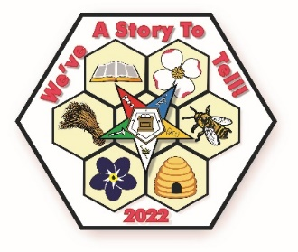
REGION L
2022 EDUCATIONAL OPPORTUNITY #2
SATURDAY, NOVEMBER 13, 2021

SWARM
Sisters and Brothers Working at Reaching out to Many
2022 WGM Cindy Chadwell, 2022 WGP Scott Riddle
and
2022 GRAND OFFICERS

N. Canton Masonic Temple
805 Orchard Avenue, NE
N. Canton, Ohio 44720

Registration
9:00 AM – 1:00 PM
Workshop #1
WGM/WGP Presentation, Conductresses Presentations,
Charity Director
Workshop #2
10:30 AM – 11:15 AM
Line Grand Meetings, Membership and Youth Committee
Lunch
11:30 – 12:30
General Session
1:00 PM – 3:00 PM
REMEMBER TO BRING YOUR AGAPE DONATIONS

