How to SEARCH the OES Website…
Click on Search
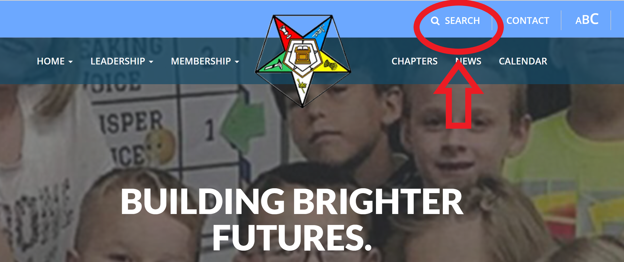

Type in what you want to see… (ex. WGM or District 21)
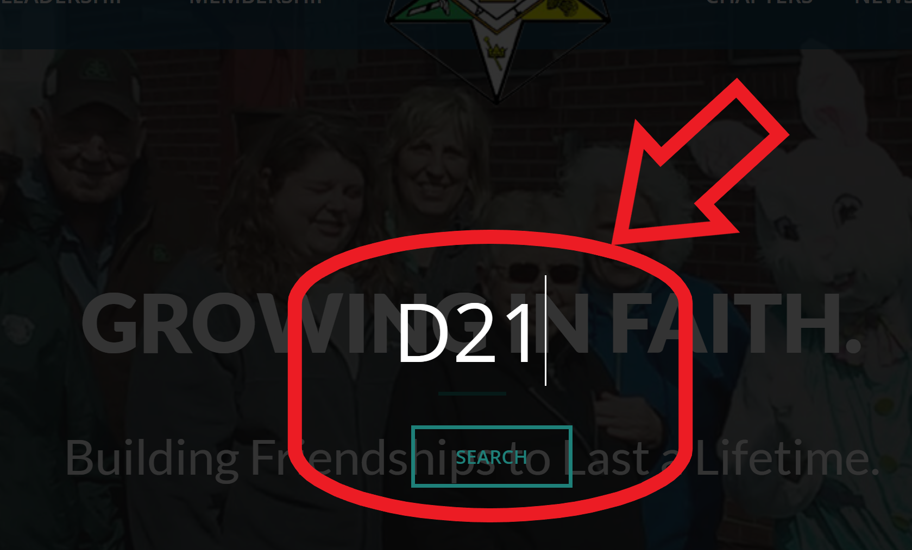

You will see a list of all the places WGM shows up in the title. Or District 21.
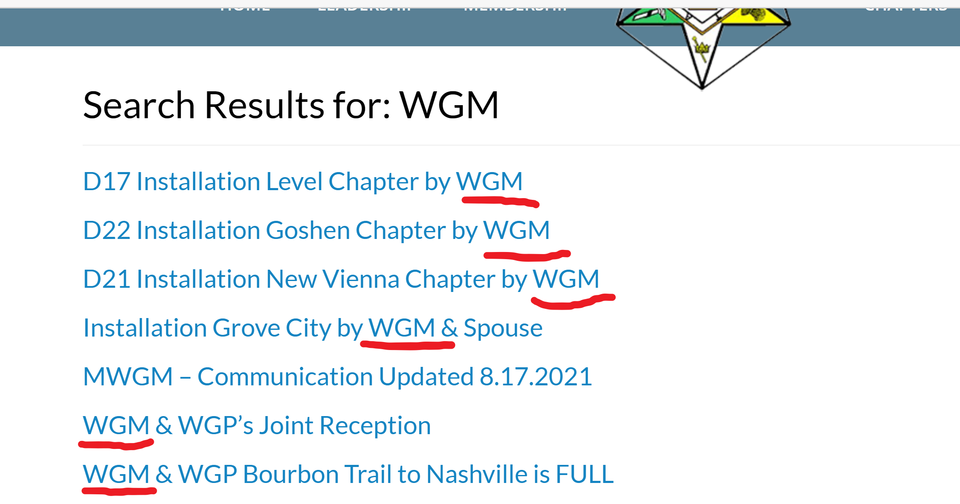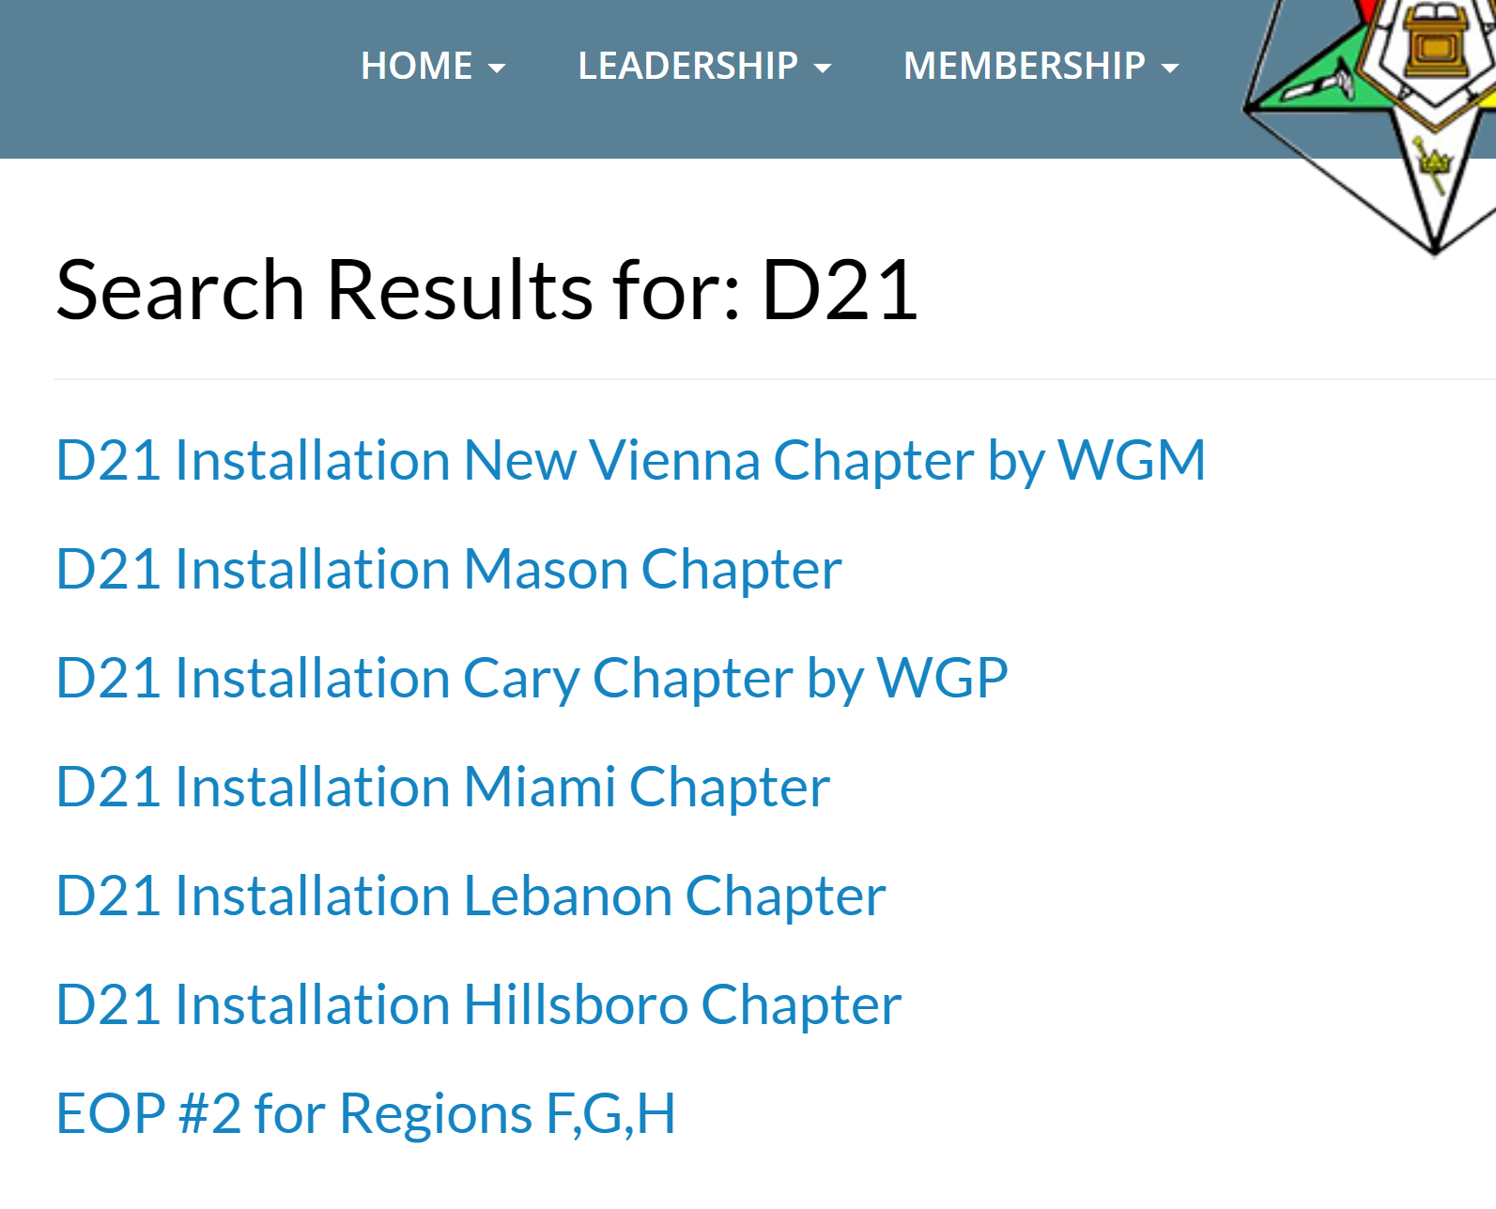

Click on the event you want to know more about.

