You are cordially invited to attend the Kentucky, Ohio, and West Virginia, Order of the Eastern Star

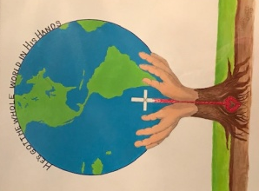
In His Hands
Tri-State Friendship Evening

Saturday, August 6. 2022
National Corvette Museum
350 Corvette Drive
Bowling Green, KY 42101

Doors open: 5:00 pm CDT
Free Museum tours 5:00 pm CDT-6:45 pm CDT
PROGRAM: 6:45 pm CDT-9:00 pm CDT
DINNER: 7:15 pm CDT
DRESS: Casual (no jeans or shorts please)

MENU:
Turkey and dressing, Roast beef and gravy
Mashed potatoes, green beans, corn, sweet potato casserole
Green garden salad, fruit salad
Cherry cheese cake, Almond Joy cake
Tea, lemonade, coffee
COST: $28.00 per person

Send reservations with check made payable to:
Lois Terkhorn
1747 Kevin Street
Ironton, OH 45638
Cell: 740-646-4188
Deadline for Reservation: July 15, 2022

Hotel reservations may be made at Sleep Inn
554 Corvette Drive, Building B, Bowling Green, KY 42101
Call: 270 904-9400 (#3 for the Front Desk or #1 for the Reservation Center)
Ask for the Eastern Star block, deadline July 18, 2022
$85 + tax (1 King bed-2 people or 2 Queen beds-4 people)

Secretaries please read at each Chapter meeting until the deadline

__________________ Complete and mail with check _______________________

Name: __________________________________________________________________

Title:____________________________________________________________________

Address: _________________________________________________________________

City: _____________________ State_____________________ ZIP_________________

