Circle of Knowledge
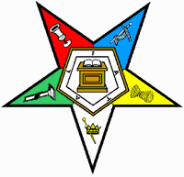
Please join us and
Test your knowledge of the Order of the Eastern Star.
The Circle of Knowledge Test will be a fifty question test given on;
Thursday, September 22, 2022 at 1:00pm
(Corrected Date)
At Sharonville Convention Center
It will include questions about: the Grand Chapter of Ohio relating to Subordinate Chapters, Book of Instructions, The Book on Protocol, and The Ritual of the Order of the Eastern Star

If you complete the test with a score of 90% or better, then you will receive a Circle of Knowledge pin on Saturday at Grand Chapter.

Register to take the test by completing the form below and mail to:
The Education Committee
c/o Jan Cosby, 25 Wildwood Lane, Mt. Vernon 43050
Or email to: jancos@yahoo.com

Name: Phone:
Address:
City & State: Zip:
District: Chapter: Number:
Email address:

