SWARM 2 / Districts 5, 6, 7, 8, 10, & 26

EDUCATIONAL OPPORTUNITY #4
PICNIC AND ASSEMBLY OF AGAPE BAGS

WGM Cindy Chadwell & WGP Scott Riddle with the 2022 Grand Officers

Saturday, June 4, 2022
Lima Masonic Center
2165 N. Cole St.
Lima, OH 45801
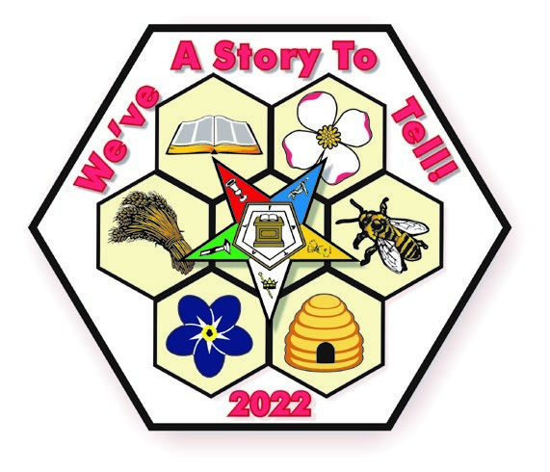

TIME SCHEDULE | ACTIVITIES
12:00 p.m. - 12:30 p.m. | Registration
12:30 p.m. - 1:00 p.m. | Picnic
1:00 p.m. - 1:30 p.m. | Education of New Members
1:30 p.m. - 3:00 p.m. | Assemble Agape Bags

CASUAL ATTIRE (NO JEANS, PLEASE)

PICNIC FARE BY THE RAINBOW ASSEMBLY OF LIMA
Shredded chicken sandwiches, chips, pasta salad, fruit and brownies/cookies.
PRICE OF LUNCH: FREE WILL DONATION
(No charge for WGM & WGP & their traveling companions, and participating youth groups)
RESERVATIONS DUE: NO LATER THAN SATURDAY, MAY 28, 2022

Mail/Email RSVP to:
VICKIE ECHELBARGER--OES.VECHELBARGER@GMAIL.COM
(1304 FAIRWAY DRIVE, FOSTORIA, OH 44830 419-436-7076 OR 419-265-2341 (CELL)

Name_________________________________________________ District_________________
Number of Meals/Attendees __________________ __________
(Additional names on the back or additional sheet of paper)

