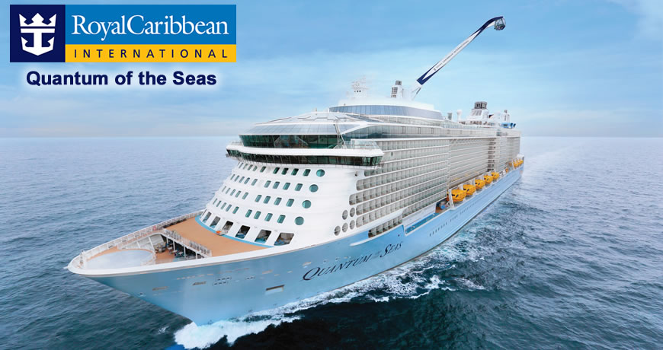
Come and join us as we make a QUANTUM LEAP for REGENERATIVE MEDICINE
Cruising to ALASKA on ROYAL CARIBBEAN QUANTUM OF THE SEAS

July 24-31, 2023

Featuring ON BOARD LECTURES FROM WFIRM FACULTY MEMBERS!
7 night itinerary includes, SEATTLE; -CRUISING; -SITKA, ; SKAGWAY, ; ENDICOTT ARM and DAWES GLACIER; JUNEAU, ; CRUISING; VICTORIA BC AND SEATTLE

CRUISE only PRICING BASED ON DOUBLE OCCUPANCY, PER PERSON RATES:
Inside: $1130.00 USD (Optional Cancellation Insurance: $69.00 p/p)
Oceanview: $1275.00 USD (Optional Cancellation Insurance: $69.00 p/p
Balcony: $1525.00 USD (Optional Cancellation Insurance: $99.00 p/p)

*Optional pre-cruise hotel package available.
*not included: Optional round-trip Transfers, Gratuities, and insurance

PAYMENT INFORMATION:
DEPOSIT OF $250.00 USD** p/p by November 01, 2022 FINAL PAYMENT due April 15, 2023
**Includes NONREFUNDABLE $100.00 RESERVATION FEE)
(Partial proceeds to benefit WFIRM (Regenerative Medicine)
Please make checks payable to Fayette Travel or provide your credit card information and sign below.
I authorize Fayette Travel Centre and Royal Caribbean International to charge my credit card the amount below and agree to pay my credit card company for these charges.

Stateroom Preference: Inside ________Outside:___________Balcony_________

CREDIT CARD NUMBER ____________________________________________________________________________________
EXPIRATION DATE: _______________________________3 OR 4 DIGIT SECURITY CODE: ________________________________
NAME AS ON CARD: _______________________________________________________________________________________
CARDHOLDER SIGNATURE __________________________________________________________________________________

Although optional, Cancellation insurance is recommended. Please initial below
INSURANCE ACCEPTED: ______________________INSURANCE DECLINED: ___________________________________________

DEPOSIT $250.00 USD PLUS INSURANCE $___________ X _____ NUMBER OF PASSENGERS: = $___________Total enclosed.

WFIRM + OES = IMAGINE

