MARY CHAPTER #9 INVITES YOU TO A RECEPTION FOR
Debbie Somerlot, Grand Warder
Grand Chapter of Ohio
Order of the Eastern Star
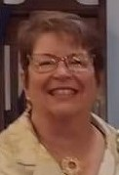
SEPTEMBER 17, 2022
Reception at 1:00 pm
Mary Chapter # 9
330 S. Main Street, Marysville, Ohio 43040

Box Lunch at 11:00 am with Sandwiches, chips, beverage and cookies.

