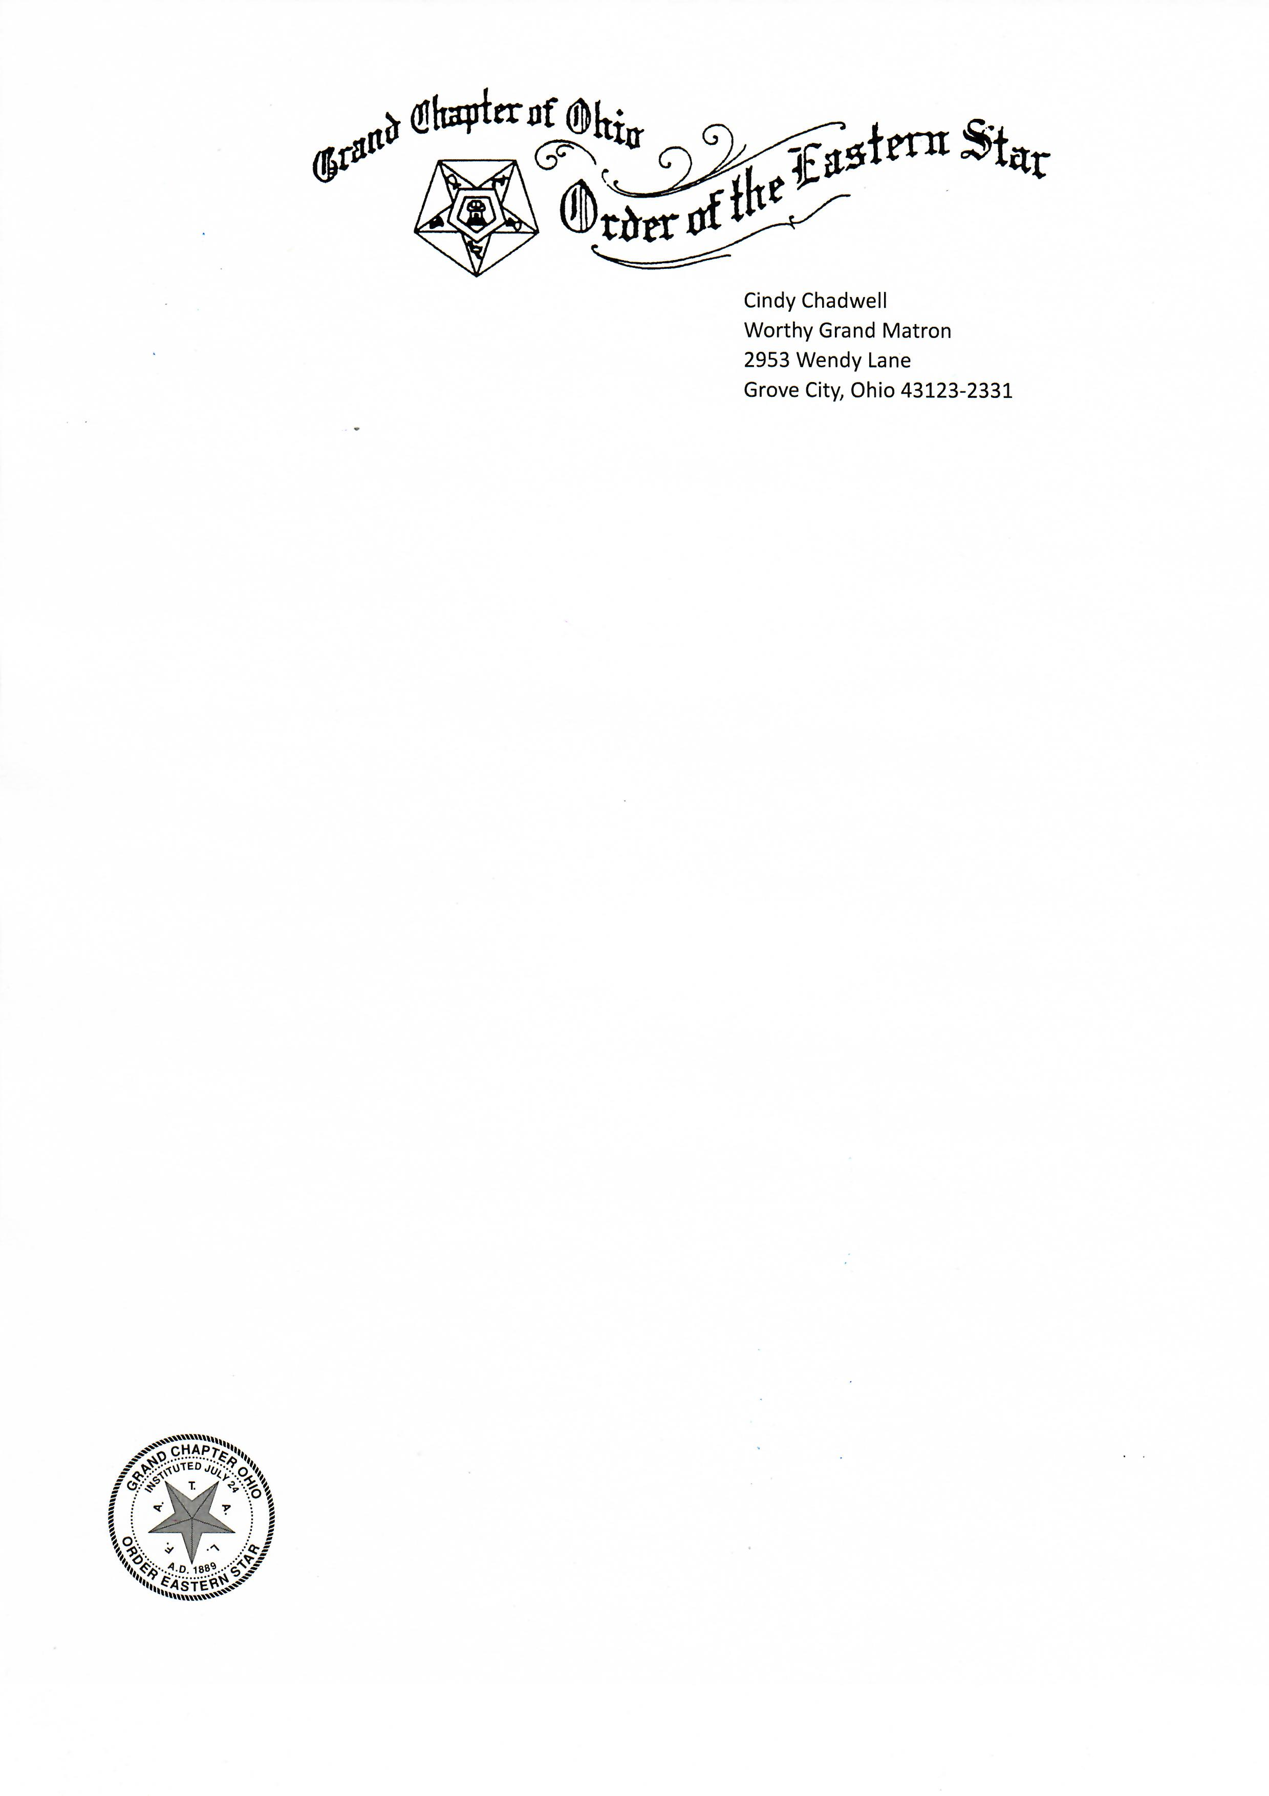

August 22, 2022

Dear Sisters and Brothers,
We hope that all of you have enjoyed a wonderful summer and had time to do some traveling and spend some time with your family and friends. We can hardly believe that the 133rd “We’ve a Story to Tell,” Grand Chapter Session in Sharonville is just over a month away, but we are rapidly finishing reports and preparing scripts and agendas for our business meetings that weekend.
A year ago, when we were installed in Sharonville Brother Scott and I each shared a “Shining Star Short Story,” about a member of each of our Chapters and asked all of the Worthy Matrons across the state have a short story prepared to give to their inspecting officer on the night of her inspection. Well, what an amazing job each of you has done in contributing to the book that has just gone to press!
We wanted to let you know that the books will be for sale outside the Grand Chapter room during the session. The cost of each book is just $10.00 and will make a wonderful gift to give to your chapters “Shining Star,” or to have available for your chapter members to read at their convenience. We are not taking presale orders and we only printed 200 copies, so when they are gone, they are gone. We hope that each chapter will purchase a copy and help us to support our Grand Chapter Benevolence Fund through the profits from the sale of these delightful books.
Thanks to each Worthy Matron that took the time to find just that right Sister or Brother to recognize for their contributions to our chapters and service to their sisters and brothers. Put $10.00 in your pocket and look for our Grand Pages at a table in the hallway, who will have copies for sale.
In Star Love,

Cindy Chadwell & Scott Riddle
Worthy Grand Matron Worthy Grand Patron

