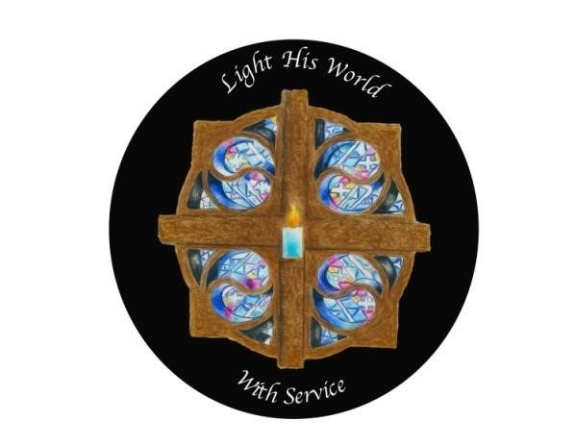
You are invited to attend the
EDUCATIONAL OPPORTUNITY #3 for Districts 5, 6, 7, 8, 10 & 26 Saturday, November 12, 2022
Presented by Debby Pitts, 2023 WGM, Rick Miller, 2023 WGP and the 2023 Grand Officers

Tiffin Masonic Lodge
181 S Washington St
Tiffin, OH 44702

Registration: 9:00 AM-12:45 PM and Shopping at the Vendor Tables

Workshop #1 9:30-10:15 AM, Choose from:
WM and WP 2023-Group discussion with 2023 WM’s and WP’s only,
Conductresses- Presentations workshop, etc. Associate Conductress- Balloting, etc.
District Charities- District Charity Directors meet with State Charity Directors
Membership Committee and Youth Committee
Workshop #2 10:30-11:15 AM, Choose from:
2023 Conductress and Associate Conductress
Group discussion with 2023 Conductress and Associate Conductresses only
2023 Associate Matrons and Associate Patrons
Group discussion with 2023 Associate Matrons and Patrons only
Secretary/Treasurer Star Points

Lunch 11:15 AM-12:30 PM, cost $13.00
Lunch menu is included on the next sheet. Please feel free to make copies
You must have a lunch reservation for lunch

Prayer Circle 12:45 PM promptly
(This will include ONLY Grand Officers, DGM from your Region, GR from your Region and Past Grands from your Region)

General Session 1:00 PM - 3:00 PM

