Bellefontaine Chapter OES #459

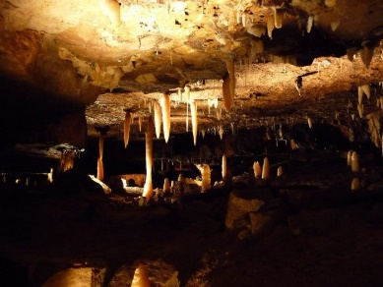
cordially invites you to attend their
Installation of Officers
on
Wednesday, October 26, 2022
7:00 PM
Bellefontaine Masonic Center
600 N. Main St.
Bellefontaine, OH
Ellen Hammond, Worthy Matron Elect
Garis Pugh, Worthy Patron Elect
Sue Griffiths, District President, Installing Officer

Home of:
Grand Representative of Montana in Ohio and District 11 2nd VP– Heather Wood
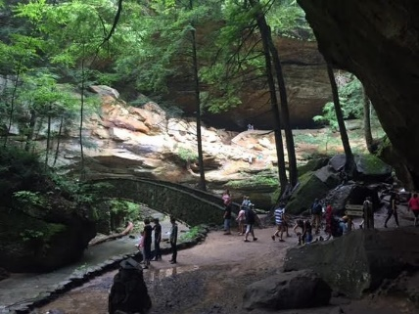
GGCC members Susan Corwin and Becky Meyer

Beautiful Ohio

