Amelia Chapter #338
Order of the Eastern Star

Cordially invites you to a

Visitation

by Worthy Grand Matron Debby Pitts and
Worthy Grand Patron Rick Miller
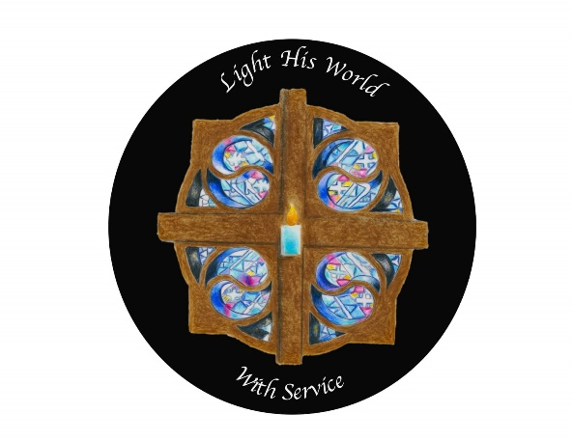
in Honor of, and a Reception for
Deputy Grand Matron of District 22
Jeni Casbar

Saturday, February 11, 2023, at 1:00 PM

Amelia Lodge
290 Judd Road
Amelia, OH 45103

Paula Baumgartner John Pierce
Worthy Matron Worthy Patron
Home Chapter of
Past Grand Patron, David Sexton
Deputy Grand Matron of District 22, Jeni Casbar
Grand Representative of Maryland in Ohio, Elyse Skiles

In lieu of gift please consider bringing an item for the Clermont County Animal Shelter
(food, blankets, toys, etc.)

“dogs are always by our sides and in our hearts”

