Covered Bridge Chapter #591
Order of the Eastern Star

Cordially invites you to a Visitation
By Worthy Grand Matron Debbie Pitts and
Worthy Grand Patron Rick Miller
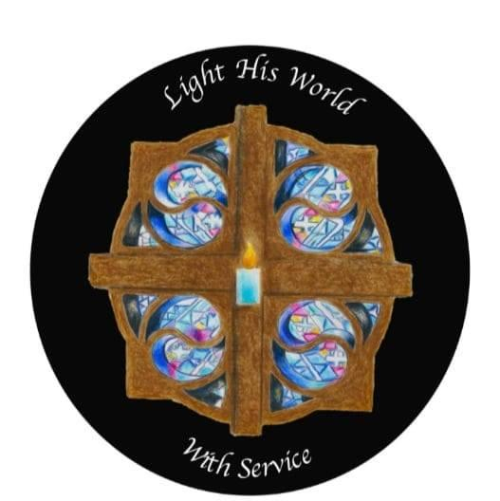

In Honor of and a Reception for GRAND ADAH Cindi Robinson

Monday, March 27, 2023 at 7:30 PM
Lenox Community Center
2509 Lenox-New Lyme Road
Jefferson, Ohio 44047

Suzanne Wludyga James Pildner
Worthy Matron Worthy Patron

