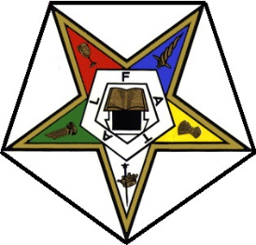
Charles R. (Bob) Higgs
Laurie Christianson
Worthy Grand Matron
PO Box 500
Northwood, ND 58267
Lau.anne@polarcomm.com
Worthy Grand Patron
2449 S. 38th Street
Grand Forks, ND 58201
bobhiggs5@gmail.com

GRAND CHAPTER OF THE STATE OF NORTH DAKOTA
ORDER OF THE EASTERN STAR

March 2023
Dear Sisters and Brothers,
It is with pleasure that we invite you to join us at the 128th Annual “Angels Among Us” Grand Chapter Session, to be held June 8, 9 and 10, 2023 at the Ramada Inn in Fargo, ND.
At the session we will conduct the business of Grand Chapter as well as allowing us time to visit with our guests, make new friendships, and renew old acquaintances. Please encourage any members initiated in 2022-2023 and members who have fifty or more years of membership to attend and be recognized for their accomplishments. Reports will be given at Grand Chapter on the different committees.
All North Dakota members are voting delegates. Everyone checking in for the session will be asked to show their dues card.
The Grand Family has thoroughly enjoyed visiting with all the Chapters throughout the state since June of 2022. We look forward to seeing you at Grand Chapter and returning the hospitality, fun and fellowship. Please plan on staying for the Saturday afternoon Grand Chapter installation as we welcome AGM Darlene Spooner and AGP Richard Bushaw to their upcoming year.
In Star Love,

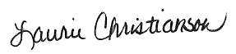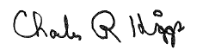
Laurie Christianson Charles R. (Bob) Higgs Worthy Grand Matron Worthy Grand Patron

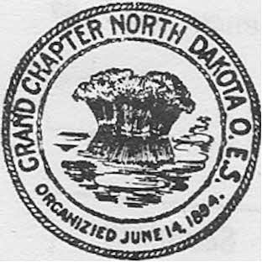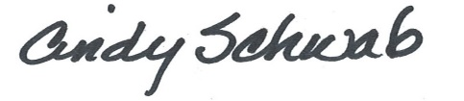
Grand Secretary

