Circle of Knowledge
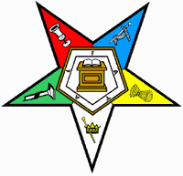
Please join us and
Test your knowledge of the Order of the Eastern Star.
The Circle of Knowledge Test will be a fifty question test given on;
Thursday, September 21, 2023 during the day
At Sharonville Convention Center
It will include questions about: the Grand Chapter of Ohio relating to Subordinate Chapters, Book of Instructions, The Book on Protocol, and The Ritual of the Order of the Eastern Star-

If you complete the test with a score of 90% or better, then you will receive a Circle of Knowledge pin on Saturday at Grand Chapter.

Deadline for registration is September 18, 2023.

Register to take the test by completing the form below and mail to:
The Education Committee
c/o Patrick Loudin, 212 Tal Shroyer Dr, New Carlisle, OH 45344
Or email to: patrickloudin@yahoo.com
-
Name: Phone:
Address:
City & State: Zip:
District: Chapter: Number: Email address:

