CHAPTER PARAPHERNALIA AVAILABLE
The following Paraphernalia is available free of charge to any Chapter that can use it.
As you are probably aware, we have Chapters that are in the process of merging and have paraphernalia that is in good shape and perhaps can be used by others. Evelyn Hardesty will be the initial contact and then will refer you to a person of the Chapter involved. The interested party will need to arrange for pick up of the items. Folks may contact Evelyn via e-mail at erhard@embarqmail.com or by phone at 614-206-9133 (cell).

Chapter paraphernalia available:
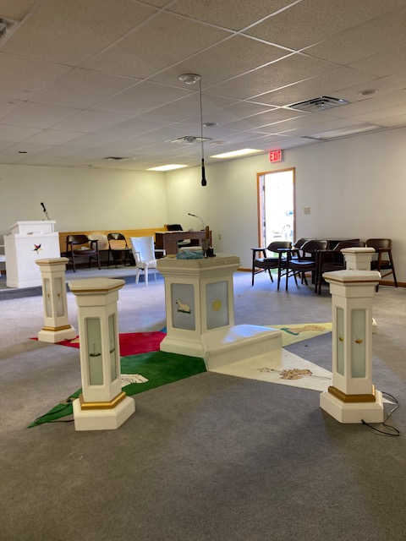
One complete set of lighted white pedestals, used at the Star Point stations. (picture attached); located in the Columbus area, Wahneta Chapter;
One lighted Altar, white with padded top; one OES podium; all in nice condition
located in the Columbus area, Wahneta Chapter (Picture attached);

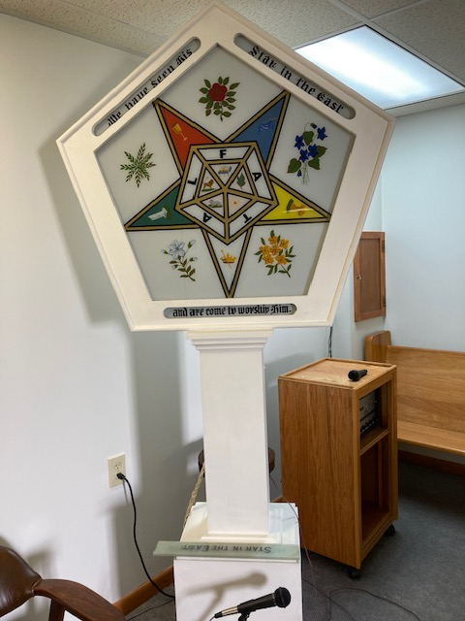
One white lighted signet; has a hairline crack in the glass; located in the Columbus area, Wahneta Chapter

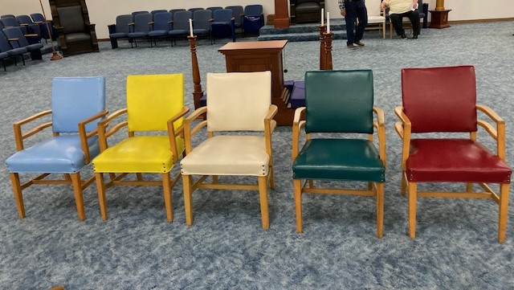
One set of 5 colored Star Point Chairs; located in Heath (outside of Columbus), Wroena Chapter (picture attached)

One Adah sword and veil (light blue); located in Columbus area, Wahneta Chapter

Ohio Grand Chapter Proceedings from 1905 thru 1949. All in good condition. Located in Columbus area; Wahneta Chapter.

Two dark wood signates; located in Johnstown.

