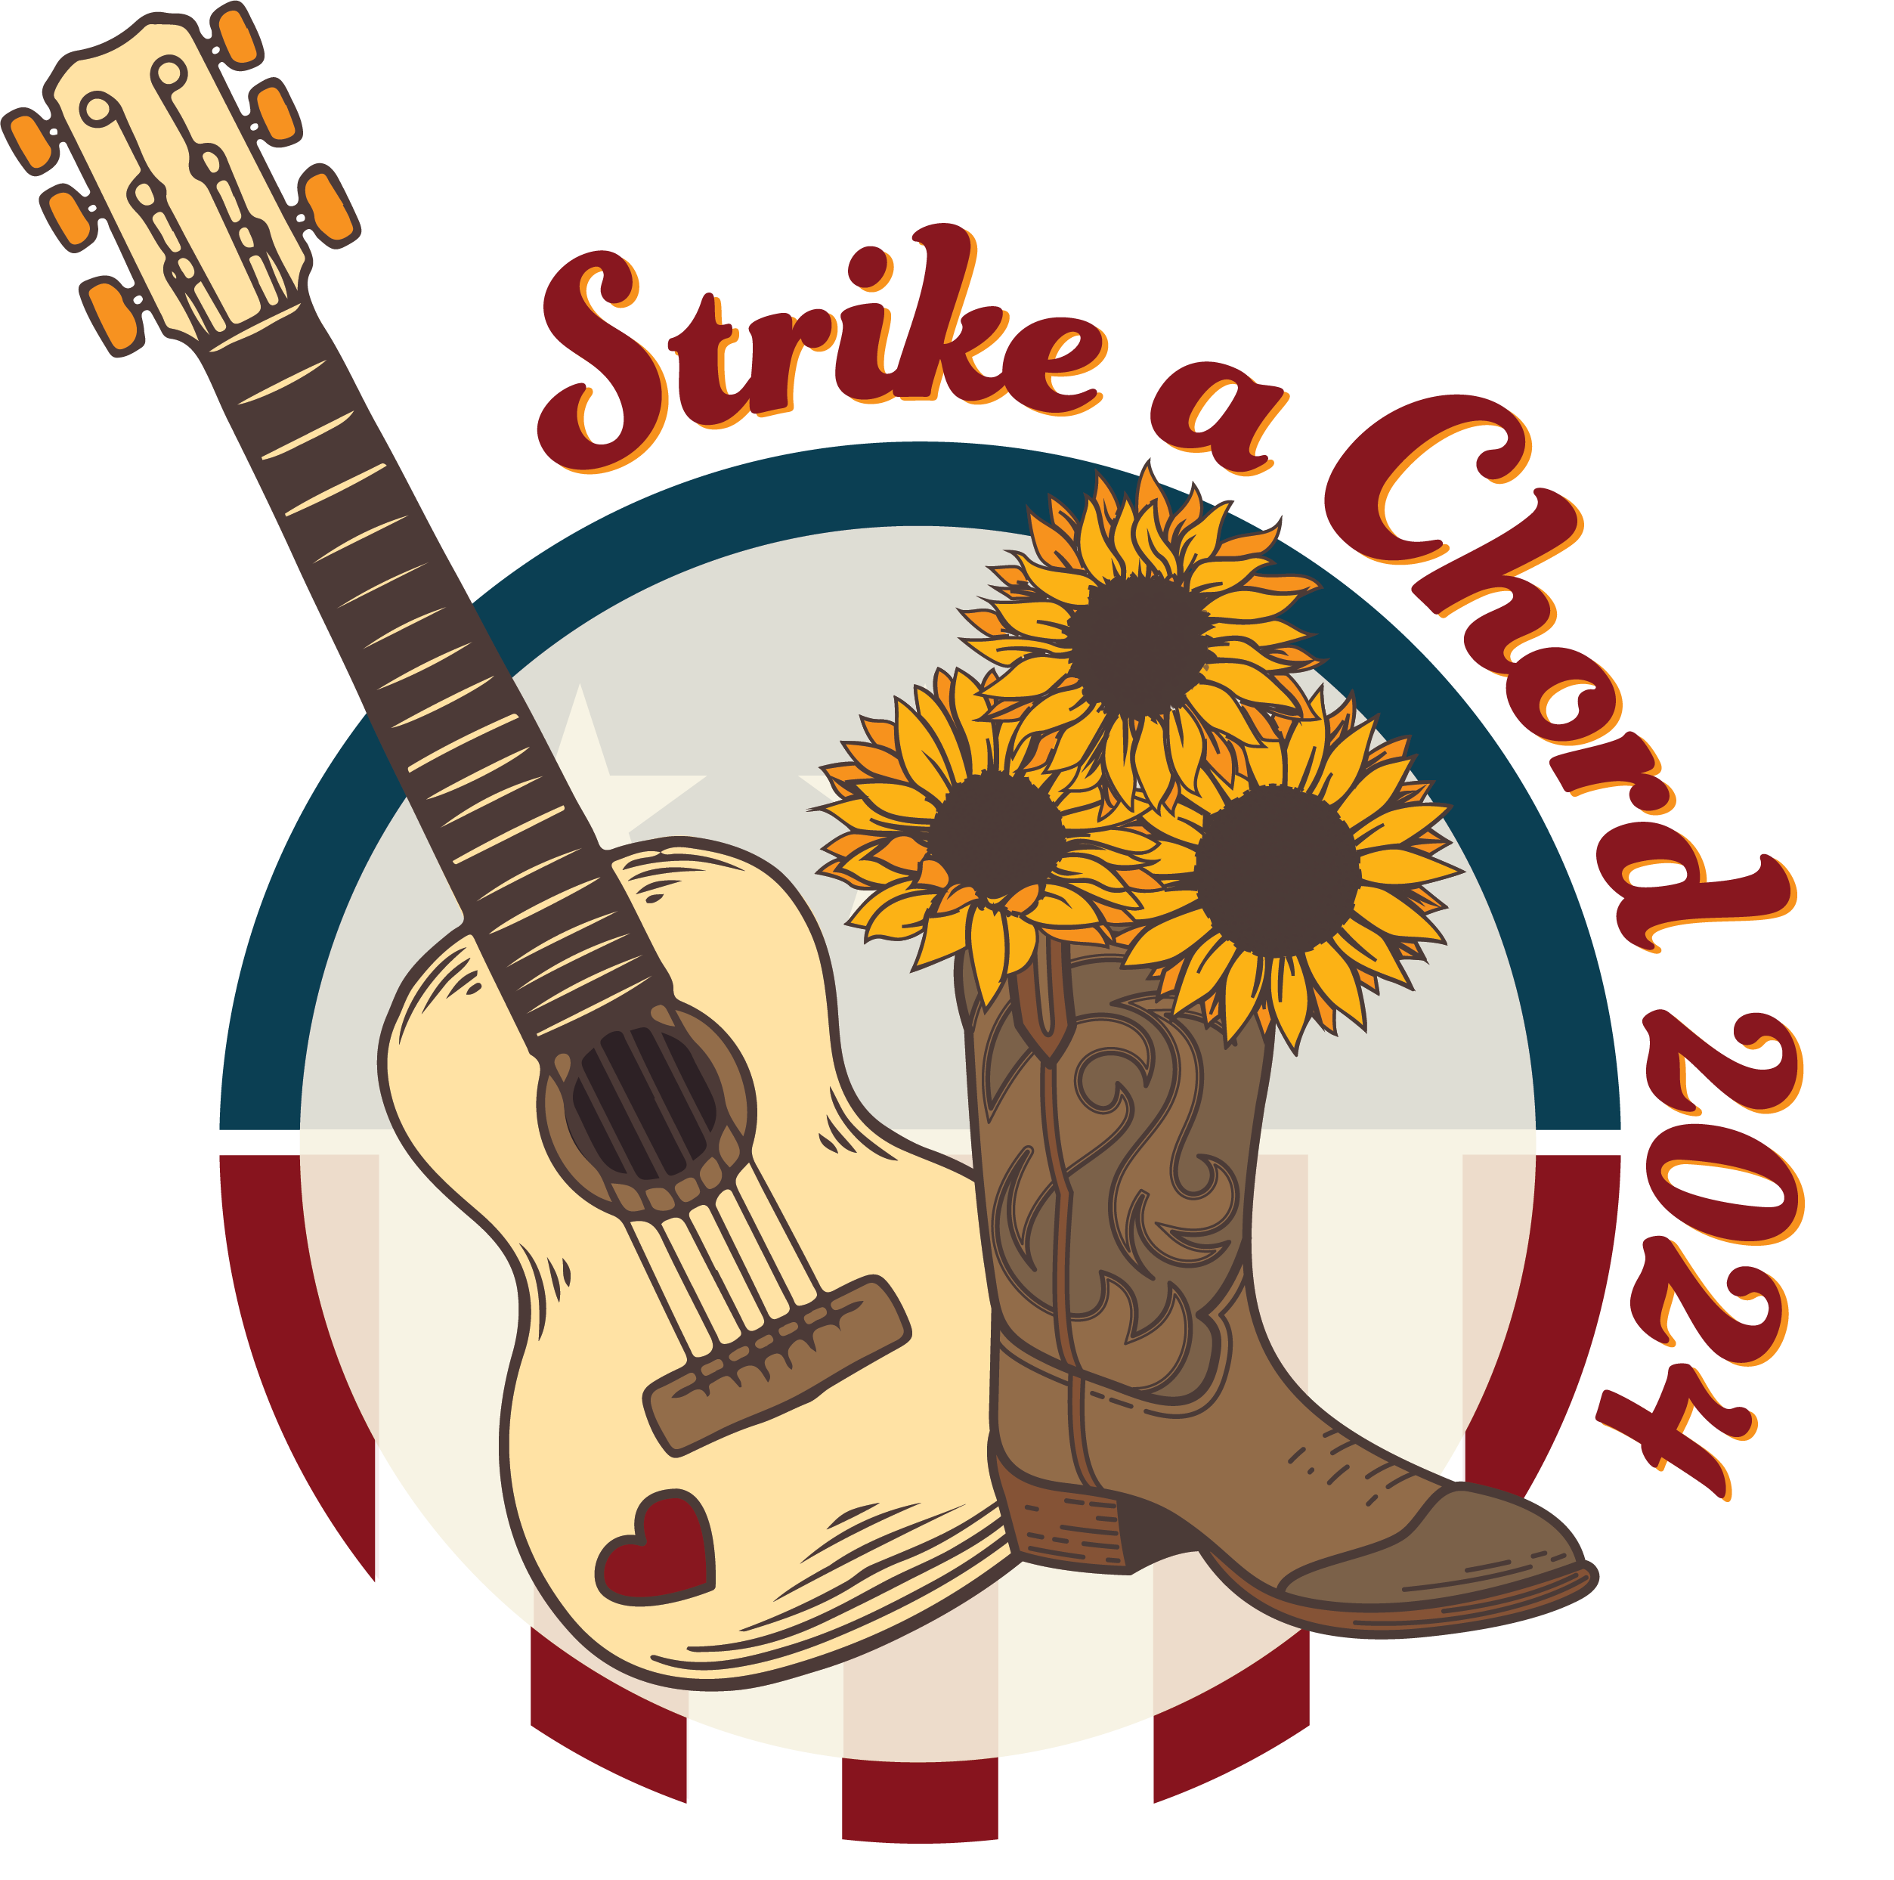

DISTRICT #12 LKM DINNER

When: Saturday, February 24, 2024
Gathering at 5:30 p.m. – Dinner at 6:00

Where: Masonic Complex
875 Irving Wick Drive West
Heath, OH 43056

DINNER will be served at a cost of $30 per person. The menu is:
Gluten free Chicken Breast w/garlic & herb flavoring
Red Skin Potatoes
Vegetable Medley
Salad w/choice of dressing, Rolls
Assorted pies & cakes, coffee, iced tea or lemonade

Send meal reservations to:
Jan Cosby
25 Wildwood Lane
Mt. Vernon, OH 43050

Make checks payable to: District 12 Association of Chapters

Firm Deadline for reservations is: February 12, 2024

LUNCH is available for DMG’s, Grand officers and others attending training at a cost of $10.00 with meat and cheese tray with buns, potato and macaroni salad, cookies, iced tea, or lemonade. Cost can be included in same check with dinner.

