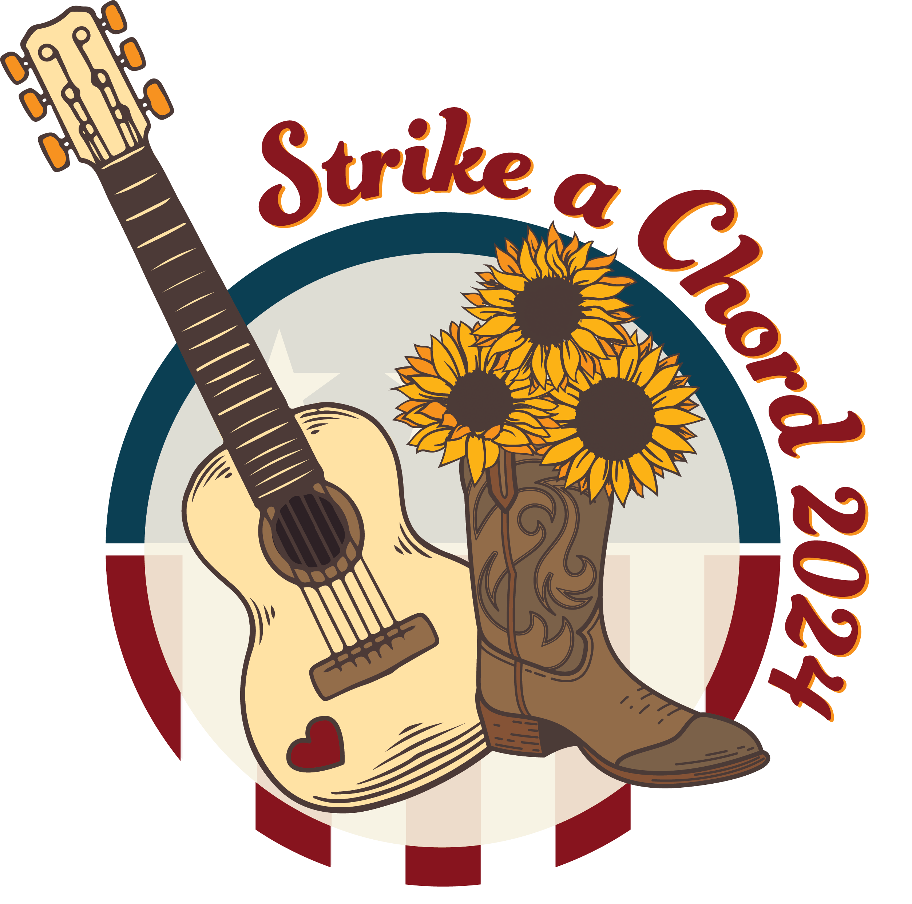

EOP #3 ZONE 5
DISTRICTS 24, 25, & 27

Who: Come One, Come All

What: An evening of Learning and Fellowship

When: Friday, March 1, 2024
Registration starts at 5:30 p.m.
Session Starts at 7:00

Where: Athens Masonic Lodge
12 W. Carpenter St
Athens, OHIO 45701

Why: Let us learn and have fun with our fellow OES family

Dress: Casual, but please no jeans

Bring: Your Ritual, Red Book, pen or pencil, and 2024 Calendar

Plan to See You There!

