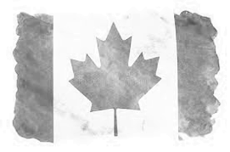
GRAND CHAPTER OF BRITISH COLUMBIA AND YUKON
113th Grand Chapter Session
TRUE PATRIOT LOVE
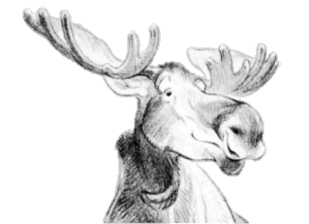
June 3, 4, 5 2024
Oliver Parks and Recreation Complex
6359 Park Drive, Oliver, BC
PRE-REGISTRATION FORM

Your Name (for Name Tag): | Click or tap here to enter text.
Address: | Click or tap here to enter text.
Phone #: | Click or tap here to enter text.
Chapter name and # in BC & YK:  Outside Jurisdiction: | Click or tap here to enter text.
Email address: | Click or tap here to enter text.
Position at Grand Chapter one or more of the following:
Distinguished Guests: | Click or tap here to enter text.
Grand Chapter Officer: | Click or tap here to enter text.
Grand Representative: Jurisdiction | Click or tap here to enter text.
Chapter Officer: | Click or tap here to enter text.
Are you a Golden Star? (50 Yr. plus Member) How many years? | Click or tap here to enter text.
Any other information:
Click or tap here to enter text.

Deadline for pre-registration by mail before Wednesday, May 17, 2024
By email and e-transfer accepted until Monday, May 24, 2024
Include this form, your Credentials (only for members of British Columbia and Yukon) and cheque or money order in the amount of $60.00 payable to “COMMITTEE ON ARRANGEMENTS 2024”
- Submit form(s) and payment by postal mail to:
Jan Rivers, 2804 Killarney Drive, Prince George BC V2K 3L1 or
- Submit form(s) by email & e-transfer $60.00 to BCYCOA2324@gmail.com (no password needed)
- We will accept USD at par.
No credentials needed for members out of Jurisdiction.

If you have any questions, please contact me at the above email or call me at 250-983-8511
Jan Rivers, Chair
Registration Committee

