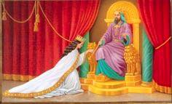

Star Point Honor Night

We hope that you will join us at
Grove City Chapter No. 502,
as we honor the Heroine’s of our Star
Thursday, March 14, 2024
At 7:30 p.m.

If you are currently serving as any of the five Star Points,
or have ever served any of those stations,
please plan to join us.

At Grove City Masonic Lodge
3558 Park Street
Grove City, OH 43123

