“Mele Kilikimaka”
Enjoy Christmas Vacation
at the Beach
at District 1
Beach Attire

Ugly Christmas Sweater
OES Charities
Fund Raiser

Sunday, April 28, 2024
2:00 PM – 4:00 PM
Donation $10.00
LOCATION!
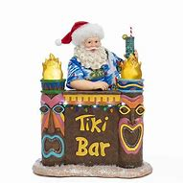
PIE AUCTION!
Get Tickets from the following:
Clara Nichols 440-354-6695
Jayne Shaffer 440-265-5078
Donna Thomas 440-478-0845
Email: dgm12k@gmail.com

Reservation Due by April 20, 2024

Painesville Masonic Temple Pie Donations Welcome
88 North Clair Street Buy a Pie for a Good Cause!
Painesville, OH 44077 Meal Includes:
Pulled Pork Sandwiches
Potato Salad
Veggie Tray
Hawaiian Wedding Cake

