Dear Sisters and Brothers,
We invite you to pack your suitcase, grab your friends and set your GPS to Fargo, North Dakota. The 129th Grand Chapter Session, “Adventure Awaits” will be held June 6, 7 and 8, 2024 at the Ramada by Wyndam. The General Grand Chapter officers and committee members lead by Glenda Winchester, Most Worthy Grand Matron and Lon Lowry, Most Worthy Grand Patron will be joining us.
The Headquarters hotel will be the Ramada, 3333 13th Ave S Fargo (701-235-3333}. The hotel information sheet including rates is enclosed. There will be a small block of rooms at the Holiday Inn Fargo. The address and phone for the Holiday Inn is 3803 13th Ave S (701-282-2700).
General Grand Chapter officers please complete the Flight information, if you need a ride from Hector International Airport. The airport does offer taxi, Uber, Lift and rentals if desired.
Thursday, June 6th, pictures will be taken in the Grand Chapter room starting promptly at 12:30 pm. Distinguished Guests introductions will take place that evening followed by the Basket Auction. On Friday evening, June 7th we have some special visitors joining us.
For those with more than one title, please pick the one you want to be escorted and introduced under but list all of your titles.
If you have any questions, feel free to contact Cheryl Siirila PGM, Registration Coordinator, at crs.sai63@gmail.com or 701-361-1254. We hope your travels are safe and looking forward to seeing you in June!
In Star Love,
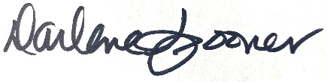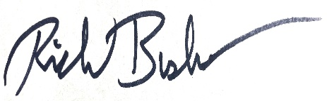
Darlene Spooner Richard Bushaw
Worthy Grand Matron Worthy Grand Patron

