SOUPTASTIC SATURDAY!
TO BENEFIT REGENERATIVE MEDICINE
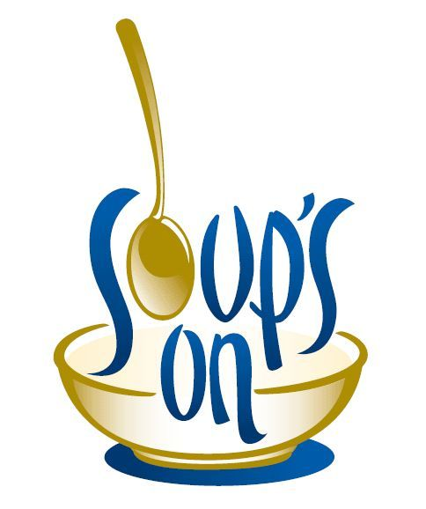

DATE: SATURDAY, APRIL 13TH
TIME: 12 NOON TO 4 P.M.
WHERE: SYLVANIA PYRAMID LODGE
3510 N. HOLLAND SYLVANIA RD. TOLEDO, OH 43615

Attention all soup and dessert chefs.
Enter your favorite crockpot of soup, chili, stew or dessert in our contest.
The winners will receive an award for the best soup and dessert.

The cost of the meal is $10.00, it includes:
Soup, salad, bread, crackers, dessert and beverage.

Text your entry to Linda Taylor (419-410-3519).

LET’S SEE IF WE CAN RAISE A LOT OF MONEY
FOR A VERY GOOD CAUSE!!

