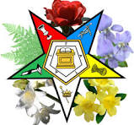

Delphos O.E.S. #26 Inspection of Chapter & Officers
Will be held at the Lima Masonic Center 2165 N. Cole Street Lima, Ohio
Tuesday April 2, 2024 7:00 P.M.
Inspecting Officer – Cheryl Maslowski WGM
Robin Stewart WM Tim Larimore WP
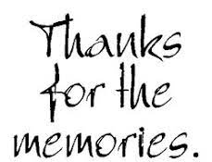

We do this together as we make memories to store within our hearts!
