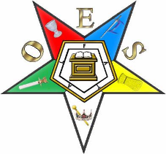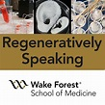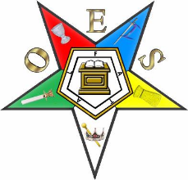
YOU’RE INVITED!
Ohio OES has been invited to join MISSISSIPPI and MISSOURI in a quick visit to WFIRM!

May 13-15, 2024

$215.00 per person, based on double occupancy.

Price includes:
- 2 nights accommodations at the Historic Brookstown Inn
- VIP TOUR of WFIRM and private meeting with Dr. Antony Atala, director of WFIRM
- Lunch and dinner with faculty of WFIRM
- Hot buffet breakfast, wine and cheese reception, cookies and milk (at bedtime) at the
Brookstown Inn
- All taxes and gratuities

We will be driving separately to NC (not a bus) so hopefully, you can come and join the parade!!

Please make checks payable to Fayette Travel Centre, PO Box 266 Mt. Sterling, OH 43143
(if paying by credit card, there is a 4% service fee).

Yes, put me down for _____ people @ $215.00 per person (Single $370)= $________________

Name_________________________________________________________________________

Sharing with: __________________________________________________________________

Address: ___________________________________City__________________________State________

Phone: ____________________ Email: ____________________________________________

